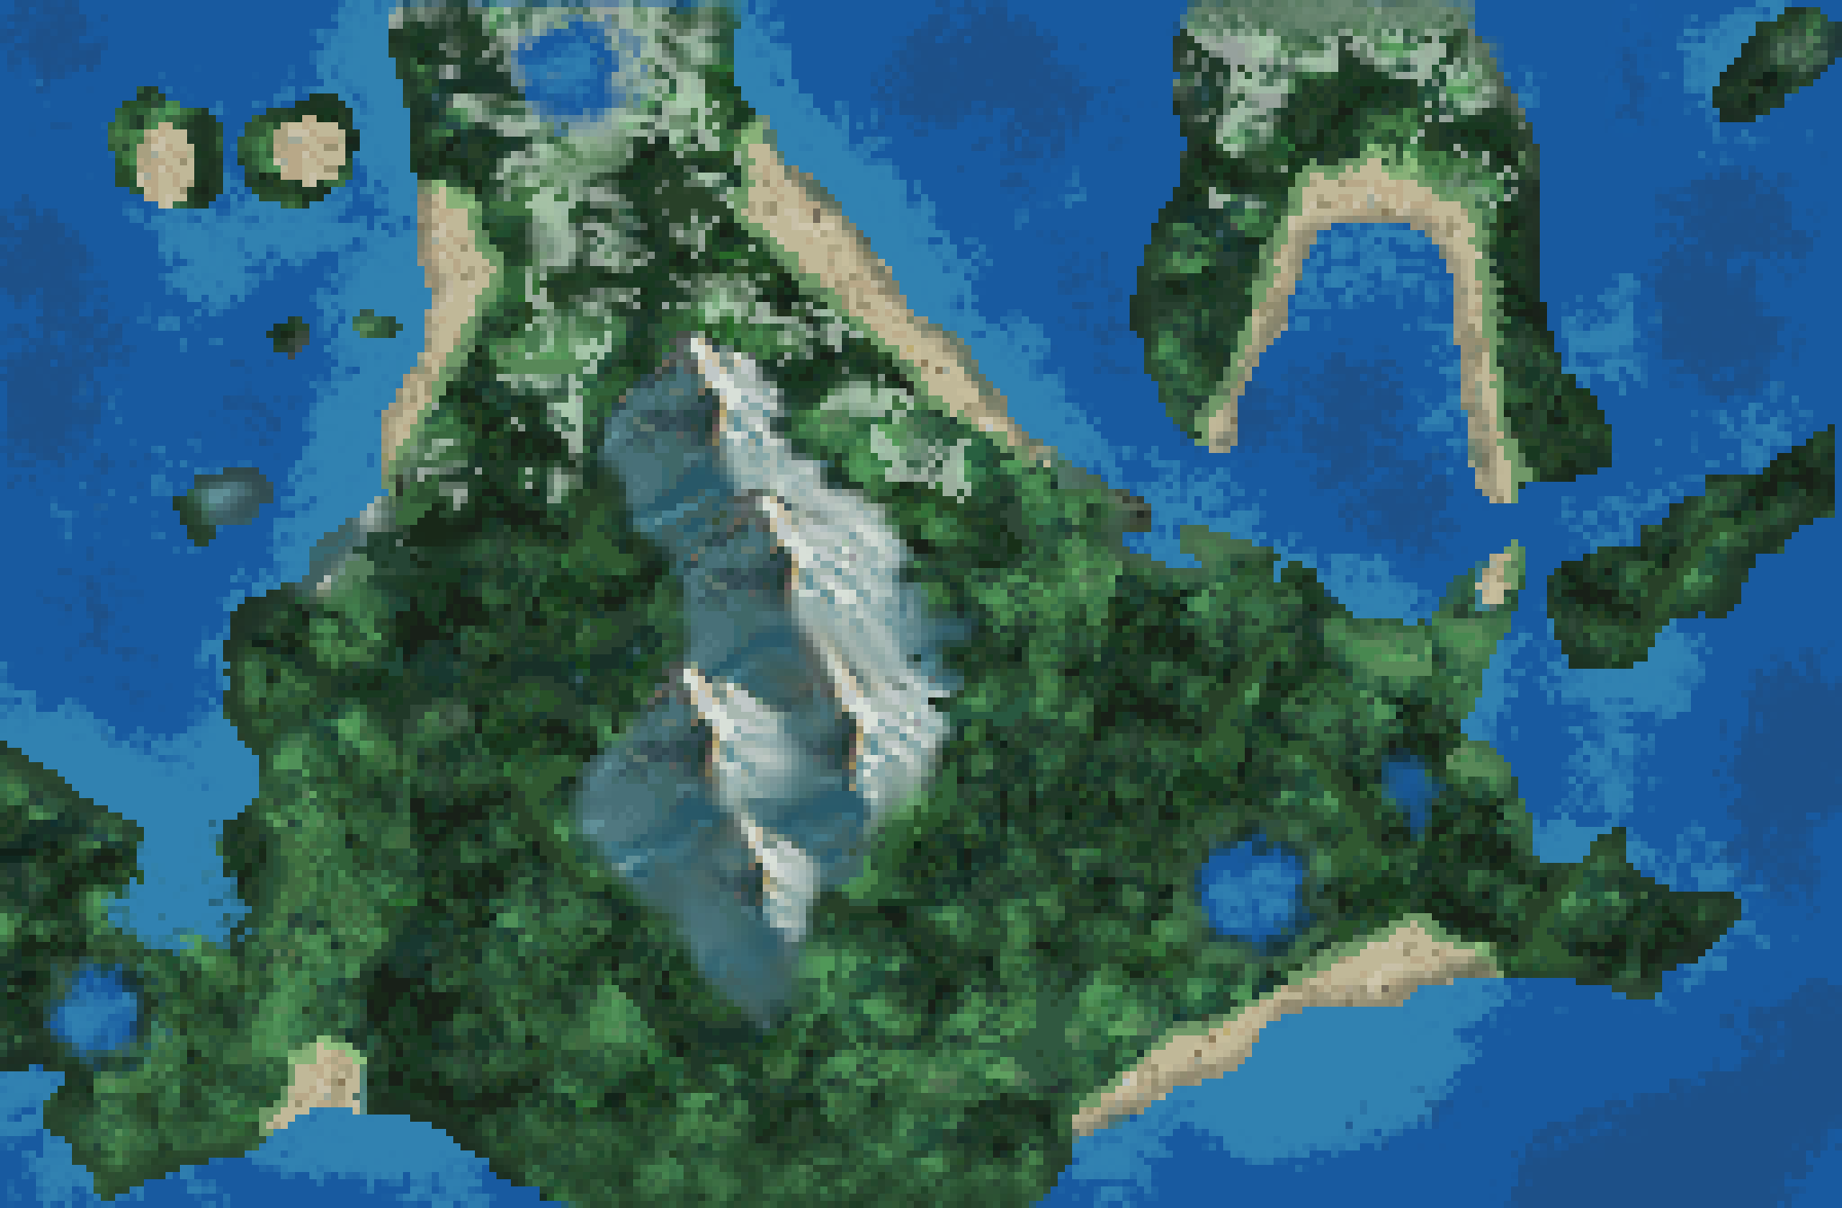

|  |
| --- |
| SINNOH MAP SCRIPT v1.1 |
|  |
| Made by: A. Somersault [Free to use with credit] |



# TABLE OF CONTENTS

FIRST OF ALL… 3

INSTALLATION 4

USAGE 6

CUSTOMIZATION 8

CONCLUSION 9

# FIRST OF ALL…

|  |
| --- |
| WHAT’S THIS? This script will implement for you a fancy gen-4-styled region map, with which you will be able to check not only your current position in game, but also all the places you have already visited. Moreover, you can open a detail view to read the different descriptions and further information about all the places. But how does it look like? Check the images below! |
| Top screen viewBottom Screen viewBottom Screen view in detail mode |
| |  | | --- | | **INSTALLATION**THE MOST BASIC PART IN ANY SCRIPT I guess you might be wondering “How on earth do I install this in my own game?”. So before moving on to how to control this script, let’s see how to implement it.   1. **INSTALL SUSc:**   Go to this [**link**](https://reliccastle.com/resources/645/) and install SUSc v4.0 or newer.   1. **INSTALL SM_Maps_Utilities:**   -Go to this [**link**](https://reliccastle.com/resources/715/) and install SM_MapsUtilities v1.0 or newer below SUSc but above main.  -Note: Make sure you also download the pack that comes with it.   1. **INSTALL this script:**   Copy the contents of the code file you can find in this [**link**](https://reliccastle.com/resources/716/) and paste it below Maps Utilities Script but above main. After this, the script section should look similar to this:  Texto  Descripción generada automáticamente   1. **Unpack the resources:**   The Sinnoh Map script kit includes different folders with graphics and files inside of them.   * First, extract the folder SinnohMap into the Pictures folder, like this:      * Next, go inside this folder and rename the file “SinnohMap.png” with the name of your actual region. (if you don’t know the name go to townmap.txt and look for **Filename=[the_name_you_are_looking_for]**) * Finally, extract the audio files into the SE folder.   **AND THAT’S IT!** |  **USAGE**THE MOMENT YOU’VE BEEN WAITING FOR At this point, you should now have a perfectly working Sinnoh map system. Now, the real question: How does it work? This script provides lots of parameters to play with, so let’s see them one by one. Well, let’s first check how to even call the script. And that’s as simple as calling **pbSinnohMap**. You won’t need to worry about in which region you are currently in, since the script itself works it out. Here’s how it looks depending on whether the constant DOUBLESCREEN from SUSc is set to true or not (aka, [**single**](https://youtu.be/IaCTzRlQ7sc) or [**double**](https://youtu.be/pBGuGXT1bCo) screen mode):  Disclaimer: the screen size itself WON’T change just by enabling DOUBLESCREEN switch. In other words, it is not something inside this script’s bounds. |

Ok, so now that you have got used to the script, let’s see how to customize it.

PARAMETERS:

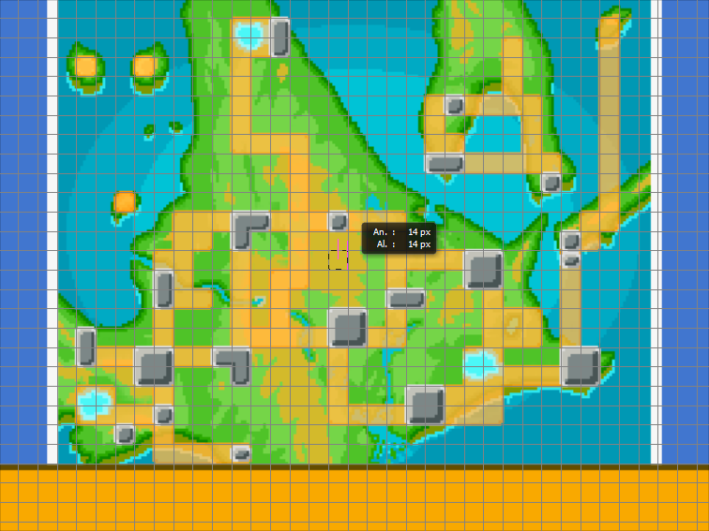-TILE_SIDE: Width and height of each map tile. You’ll have to take this into account when drawing your own map. Here’s an example with TILE_SIDE==14:

-MAP_WIDTH_TILES: Number of useful horizontal tiles (I’ll explain more about this just below)

-MAP_HEIGHT_TILES: Number of useful vertical tiles (I’ll explain more about this just below)

-X_OFFSET: Margin in tiles from the left side of the screen. The cursor won’t be able to access these columns. In the example above, X_OFFSET == 2

-Y_OFFSET: Margin in tiles from the top side of the screen. The cursor won’t be able to access these columns. In the example above, Y_OFFSET == 0

-ICON_NAME_M: Name of your male player icon (you can either change it with your custom one or keep the same name and just replace the base sprite)

-ICON_NAME_F: Name of your female player icon (you can either change it with your custom one or keep the same name and just replace the base sprite).

-BLINKING_TIME: Blinking period in frames of the cursor

-CSMOVEPERIOD: Delay in frames of the cursor movement. Always 1 or greater.

-MC_MOVEMENT_TIME: Frequency in frames of the (orange) minicursor

-CHANGE_PAGE_SE: Name of the sound to be played when switching detail mode on and off.

-EXIT_MAP_SE: Opening and closing sound

-LOC_NAME_X and LOC_NAME_Y: Coordinates of the location names of the top screen.

-SHOW_DESC_ON_ROUTES: Whether the description should be shown when the cursor is over a route.

AND THAT’S IT!

CUSTOMIZATION

BECAUSE YOU MIGHT NOT WANT A SINNOH MAP BUT A [YOUR_REGION_NAME] MAP

**HOW TO ADD A NEW LOCATION:**

1. Open SinnohMap.txt
2. Scroll to the very bottom and add respectively in new lines the following (when elements inside brackets it means they are optional):
3. This string: **####################**
4. The name of your location, a comma, [the location icon to be used, a comma].
5. Location x coordinate, y coordinate, location width in tiles and location height in tiles, all separated by commas.
6. A list of maps IDs, starting with the outdoor one, that belong to the same location (at least one element).
7. [Description of the map].

Note: each line must end in a comma; each description string must be written in one single line; a Bidoof did something at Valley Windworks and now I’ve been forced to place a -1 as an icon in order to avoid all kind of disasters caused by that god.

This is an example of a location:

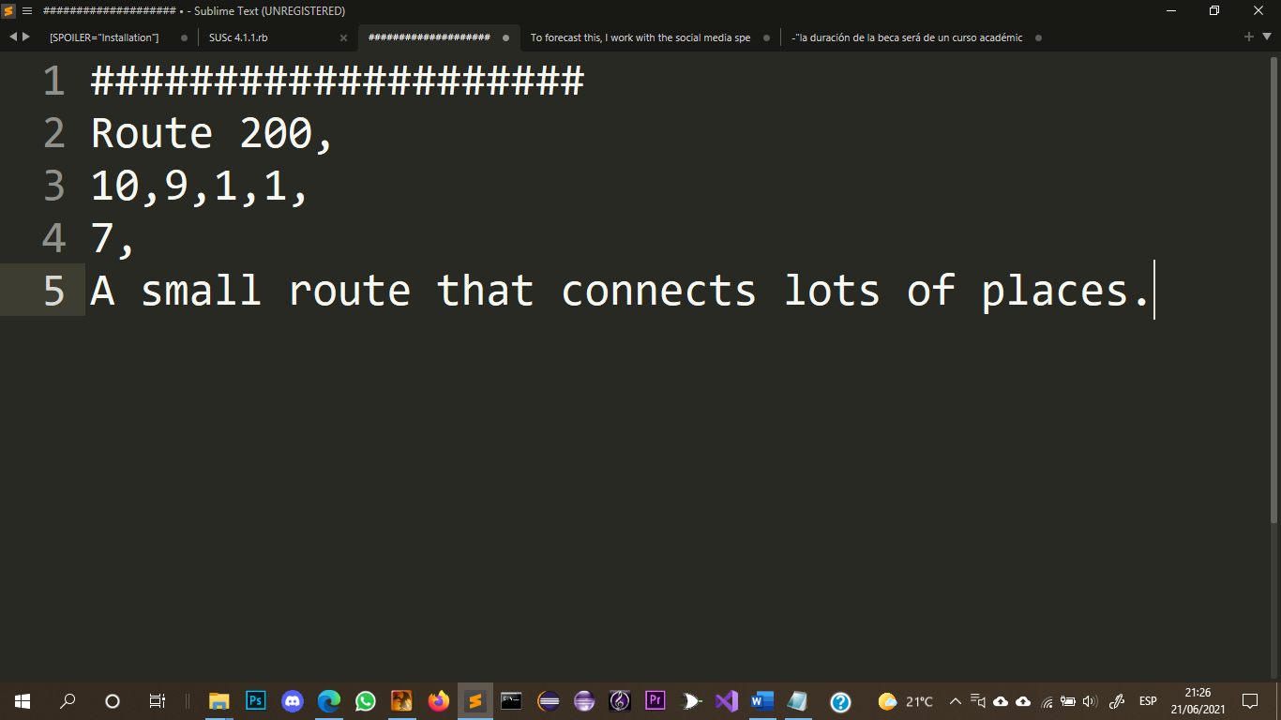

1. Optional (in case you wanted to add a minimap to the bottom screen when the location is selected): Go to Graphics/Pictures/SinnohMap/SignPosts and place there your minimap. It should have a size of 96x64, but it can be of any other. The name of this file must be the same as the location name you wrote back in step 4.

Note: There is no problem If you don’t place any image with the name of the specific location. It just won’t show anything as minimap.

DONE!

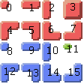

By the way, regarding the location icons: 🡪

(You can also add new ones to the graphic following the 16x16 grid)

CONCLUSION

JUST FOR THE SAKE OF GIVING THANKS (and a small spam with my sites if I may)

And this is it for this version. If you have any problem don’t hesitate to mail me at [somersault0023@gmail.com](mailto:somersault0023@gmail.com), or contact me via discord: 𝐒𝐨𝐦𝐞𝐫𝐬𝐚𝐮𝐥𝐭#9770 (copy and paste it because you are not going to find me otherwise), and I’ll be really glad to help you solve any problem with this or any other script.

I also invite you to check my [Deviantart](https://www.deviantart.com/gogoat1) account as well as the site of ahuge [Sinnoh fangame](https://project-insurgent.github.io/web/Index.html) my team and I are developing (in which this script features, by the way!)

With all being said, I would also like to give huge thanks to you. Exactly! Infinite thanks for downloading and playing with this. I really appreciate it. I really hope you like it and you enjoy it. Stay safe and best regards!

